**Introduction**

This project will address the inevitable increase in waste generated in Wales, and Wrexham will be the central focus of this study. As our communities continue to thrive, the challenge of managing the growing waste becomes more evident. To generate a solution, we will leverage data, technology, and optimization strategies to transform waste management by creating an efficient and sustainable approach.

**Dataset**

Local authority municipal waste management materials data. It contains records from 2012-2022 and captures the evolution of waste management in over a decade.

Source: <https://statswales.gov.wales/Catalogue/Environment-and-Countryside/Waste-Management/Local-Authority-Municipal-Waste/annualwastegenerated-by-source-year>

**Problems Analysis**

Fig 1

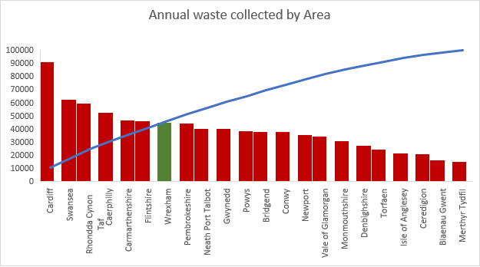

Fig 1 shows the distribution of waste collected across the local authority areas in Wales. The chart indicates an upward trajectory of waste generated within the last 10 years. An average of 1,537,520.231 tons of trash is generated each year emphasizing the imminent need for a more tactical approach to avoid straining existing resources.

Fig 2

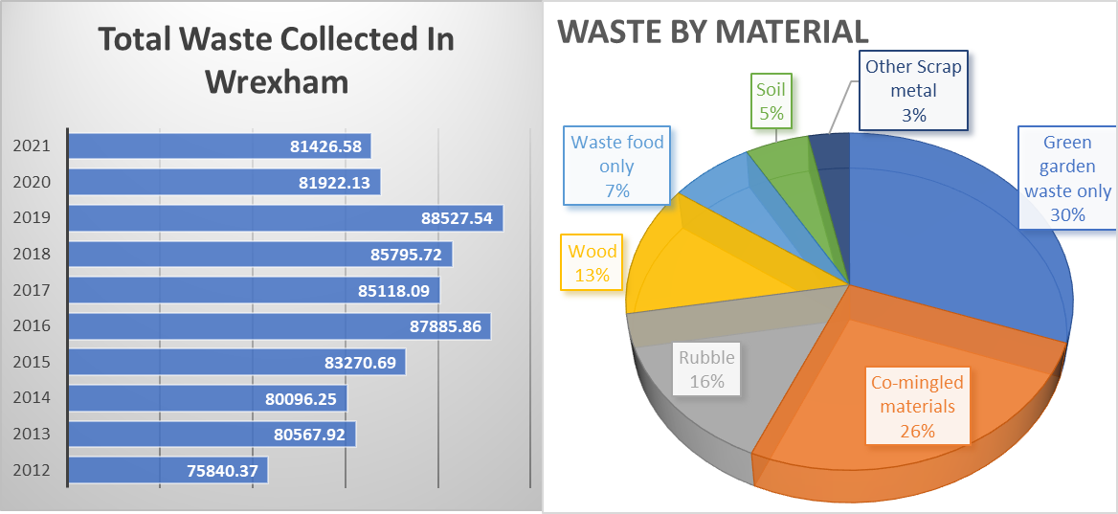

Fig 2 shows fluctuating but relatively high waste collected in Wrexham. An average of 83,558 tons of waste is generated each year from different variances of waste. The major materials collected comprise green garden waste, co-mingled materials, rubber, etc. These consistency trends indicate high residual household waste and a high possibility that Wrexham will face a persistent waste challenge if the situation is not properly and timely managed.

**Key location for the project**

SToK Racecourse, Wrexham, UK

**Rationale for selection**

SToK Racecourse is undoubtedly becoming the hub of activities in Wrexham attracting a large influx of fans, students, and visitors. The presence of a 15,000 capacity football stadium for Wrexham AFC and University adds to the vibrant atmosphere indicating the need for a proactive strategy in managing waste especially during peak periods.

**Solution**

Introduce an optimized waste collection system in Wrexham by creating an interactive map of recycling waste stations along with an algorithm that will determine the most efficient garbage collection routes to the key location.

**Methodology**

Data collection: Due to the unavailability of an online dataset containing the geographical coordinates of recycling stations in Wrexham, a manual approach will be adopted to collect data. Information on recycling stations will be obtained from the Wrexham council website, which will contain station names, addresses, and postal codes. This will be used to obtain longitude and latitude coordinates for each location from Google Maps, forming the foundation of the dataset.

Source: [Household recycling centres | Wrexham County Borough Council](https://www.wrexham.gov.uk/service/other-ways-recycle-wrexham/household-recycling-centres)

Fig 3

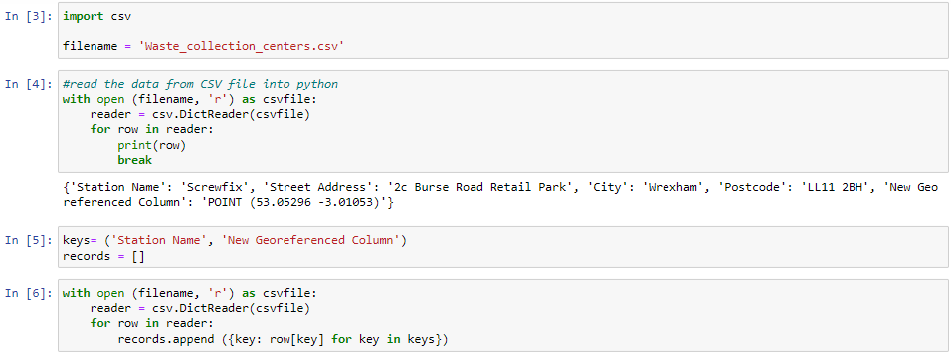

Data preprocessing: As shown in Fig 3. This stage will involve the use of an Excel spreadsheet to clean the extracted dataset and transform data into a tabular format to be imported as a CSV file into Python where the CSV library will be used to create a reader object dictionary. The split function will be initiated to extract the longitude and latitude values which will be converted to a floating-point number in other to be compatible with the folium map.

Fig 4

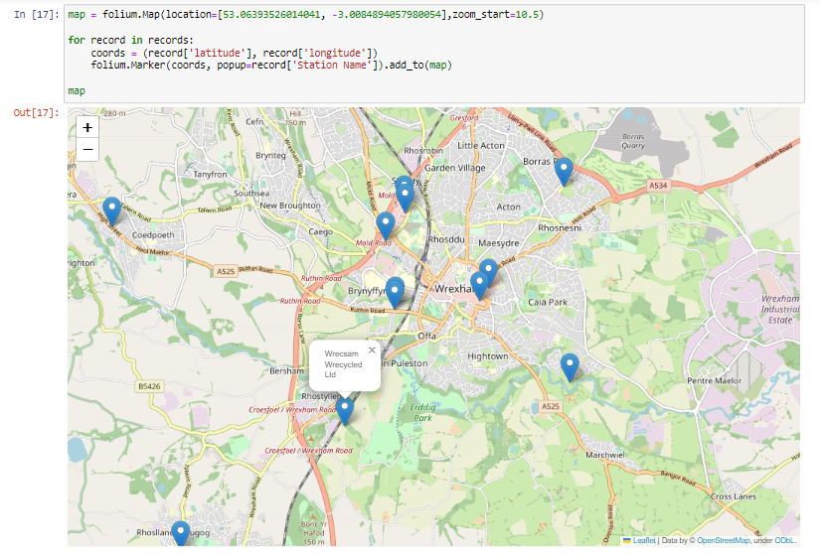

Visualization: The folium library will be used to create a map based on the longitude and latitude of each station with SToK Racecourse at the center of the map. Markers will be added to represent each of the stations and fastmarkercluster will be used to create a proximity-based cluster for each of the stations within the same district as illustrated in Fig 4.

Fig 5

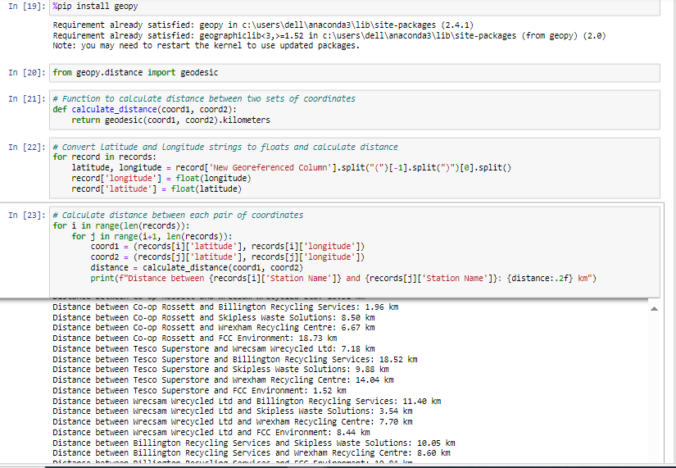

Algorithm: Utilizing the Haversine formula, the geopydistance library as seen in Fig 5 will be used to calculate the distance between SToK Racecourse and each of the stations. The folium map will display the calculated distance of each station, mark them with a popup icon, and show the proximity to Wrexham University.

Fig 6

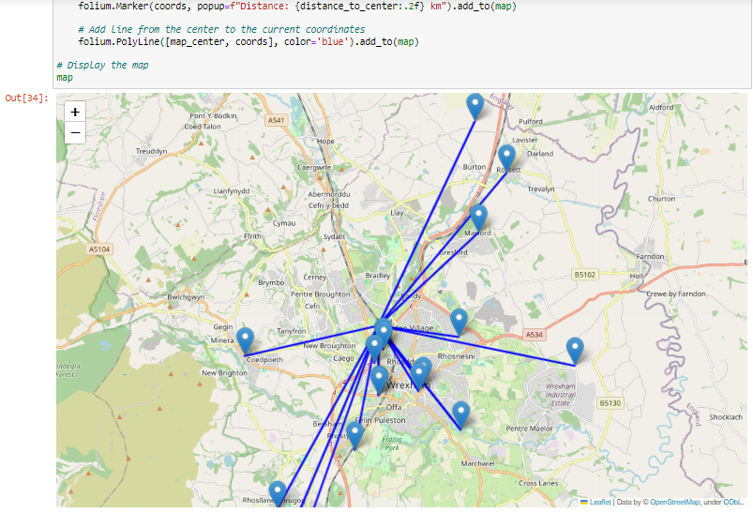

Result: Fig 6 shows a visual implementation of an optimized waste collection system in Wrexham that will leverage distance calculation to determine the most effective routes. This project will supplement the already existing resources and promote sustainable waste management practices in line with Wrexham's local development plan.